Student Name: Xianglong Lin Student Number: 45791439 Team Name: H2OMG
Week: _6_
Title: Prototyping with Arduino for Water Flow Monitoring
Description:
In the 6th week, our team moved to the implementation phase of prototyping based on user needs and issues identified from last week. To meet the demand of users for efficient monitoring tools, a combination solution of physical components and digital technology was explored. Initially, we were all hindered by our lack of experience in Arduino and backend programming, which we tried to avoid and bypass. However, after constant communication and consultation with the tutors, we gradually realised that a purely digital solution was not feasible. Therefore, we had initially developed a prototype that mainly consists of an Arduino Uno and a water flow sensor to obtain water flow data for further suggestions. Although we know that there will be technical and programming difficulties, we are confident that with the help of the tutors, we can overcome them and ultimately achieve a more comprehensive portfolio solution.
Visual Evidence:
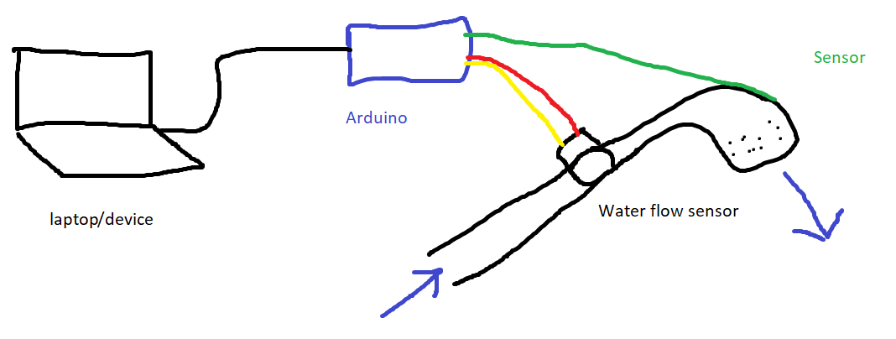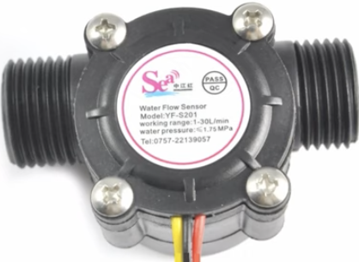
Statement on Learning:
This studio had pushed us from the theoretical stage of data analysis last week to the next practical implementation stage. The final adoption of Arduino for the project design was a significant step in overcoming our psychological fears and stepping out of our comfort zone. This demonstrated each team member's drive to improve, the willingness to face challenges head-on, and the teamwork spirit that is not afraid of difficulties. Although we only focused on identifying the need for real-time monitoring tools for water resources last week, it seems that converting conceptual stage outputs into operational models at the prototype stage is more complex than expected. This involves a range of uncertain factors such as the technical background of the team and material procurement. Furthermore, the innovative approach of integrating digital solutions with physical hardware had provided us with new insights and once again solidified our adaptability to solution design and teamwork skills. In my case, I initially proposed considerations for front-end development due to my area of expertise. However, integrating Arduino hardware quickly made me realise the importance of understanding the entire system in order to successfully design a final prototype. Although this growth will most likely make me more inevitably exposed to the backend development aspects that I previously feared, it will undoubtedly increase my backend programming skills and experience. Meanwhile, the iteration of prototype design had also begun to show, it is more practical to pursue "good enough" rather than perfection in the early stages of design. This set of learning and insight growth made the progress in our team's user-centeredness and technical feasibility.

